The Roles of Surface Free Energy and Interface Strain

in HfO2, ZrO2, and HZO Ferroelectric Formation

A. C. Kummel1, E. Chagarov1, N. Draeger2, M.B. Katz3, N. A. Sanford3, A. Davydov3, M. H. Lee4,   
1Dept. of Chem, Univ. of Cal., San Diego 9500 Gilman Drive, San Diego CA 92093, USA; 858-534-3368 akummel@ucsd.edu 2Lam Research Corporation, Fremont, CA 94538-6470 U.S.A   
3National Institute of Standards and Technology, Gaithersburg, MD 20899, USA   
4 National Taiwan Normal University, Taipei City, Taiwan 106

***Abstract*—**DFT was used to identify the sources of stability for the ferroelectric phases of nanocrystalline HfO2, ZrO2, and Hf0.5Zr0.5O2. Atom probe tomography performed on TiN/HZO/Si structures revealed selective ZrNx formation near TiN; this is consistent with partial phase separation in HZO, which would assist in the formation of small grains.

**I.**  **INTRODUCTION**

For integration of ferroelectric oxides on Si, SiGe, or Ge, the most practical choices are based on HfO2 and HfxZr1-xO2 (HZO). DFT calculations were performed to understand the possible sources of stability for the orthorhombic ferroelectric phases (f-phase) of HfO2, ZrO2, and Hf0.5Zr0.5O2 as opposed to the bulk stability of the monoclinic phases. In nanocrystalline materials, the surface (or interfacial) free energies will dominate the thermodynamic stability. Furthermore, it is known that films with high f-phase content can only be formed when the films are capped with a crystalline electrode, typically TiNx. DFT calculations were performed for all three oxides to determine if the biaxial stress or strain from quasi-epitaxial growth on TiNx could stabilize the f-phase. In contrast to doped HfO2, the composition range for f-phase formation with HZO is quite large. In the present report, atom probe tomography (APT) was performed on TiN/HZO/Si structures to determine the film composition of the interfaces for indication of possible phase separation of HZO since phase separation could promote nanocrystal formation.

**II.DFTCALCULATIONS OF BULK STABILITY**

DFT simulations were performed with VASP code using projector augmented-wave (PAW) pseudopotentials (PPs) and the Perdew–Burke–Ernzerhof (PBE) exchange-correlation functional. HfO2, ZrO2 and Hf0.5Zr0.5O2 unit cells for f-, m- and t-phases were relaxed at variable volume to optimize DFT lattice constants. HZO unit cells were optimized with 2 different placements of Hf and Zr atoms in the unit cell.

For HfO2, ZrO2, and HZO, the most stable bulk phase is the paraelectric monoclinic phase denoted as “m-phase”. The ferroelectric phase has been identified as the orthorhombic phase denoted as “f-phase” and the antiferroelectric phase has been identified as the tetragonal phase denoted as t-phase. For all the phases, the m-phase was used as the reference state and assigned an energy of 0 meV. As shown in Fig 1, the f-phase is less stable by ~80 meV per formula unit (fu) and, therefore, would only be present at significant concentration at high

temperature. These results are consistent with previous DFT calculations of the thermodynamics stability of HfO2 and ZrO2 that were performed using similar techniques [1,2]. The entropic contribution to the stability of HfO2 has been reported but was found to be a small effect [2].

**III.DFTCALCULATIONS OF SURFACE FREE ENERGY**

Early experimental work by S. V. Ushakov *et al* shows that tetragonal (or possibly orthorhombic) HfO2 and ZrO2 could readily be formed in thick solution deposited films if nanocrystals had diameters below ~10 nm [3]. More recently,

|  |
| --- |
| Kim *et al* demonstrated that for TiN/HZO/TiN thin films |
| (ALD deposited HZO ~5 nm), the mean HZO grain diameter |

|  |
| --- |
| is the dominant variable in determining the percent f-phase. |

[4] Similar experimental data was employed by Materlik *et al* to develop an empirical model for HZO to show that f-phase might have a lower surface free energy than m-phase. [1] In the present report, the surface free energies of the major low index faces of the three oxides were calculated by DFT in a consistent manner. It is noted that in a nanocrystalline films, interfacial free energy with respect to the top and bottom electrodes and the amorphous grain boundaries will determine the exact surface energies; however, the surface free energies are a good starting point to understand if there are extremely differences which might result in preferential formation of a phase of nanocrystals.

To model the surface free energies, an oxide column consisting of a 1x1x4 supercell was constructed. Vacuum layers of ~15 Ang were added, and the stacks were relaxed at 0K below 0.05 eV/Ang force tolerance. Several different surface cuts were tested for (001), (111) and (101). The cuts which provided both upper and lower surfaces with oxygen termination had the lowest energy and preserved the basic structure of the subsurface. As shown in Fig 3, the lowest energy structures of all three phases of HZO are nearly identical consisting of O atoms bonded to two Hf/Zr atoms. The nearly identical bonding configurations result in nearly identical surface free energies and are likely to result in nearly identical interfacial free energies to amorphous interfaces.

As shown in Fig 3, for any given crystal face, the surface free energies are nearly degenerate between m-, f-, and t-phases. For all three oxides (HfO2, ZrO2, and HZO), the surface free energies of the three m, f, and t phases are nearly degenerate. This means that when a nanocrystalline phase is

formed, a large fraction of the nanocrystals will be f-phase and therefore ferroelectric. It is also possible that a strong field could convert the t-phase to f-phase.

**IV.LATTICE MATCHING TO THE ELECTRODE**

To produce f-phase, the HfO2 or HZO must be deposited in the amorphous state and annealed with a top electrode typically TiNx. TEM shows regions of apparent epitaxial alignment [5]. Since TiN and Ti3N4 have different lattice constants than HfO2 or HZO, this will induce stress or strain which may stabilize f-phase. It is noted the lattice constants of HfO2, ZrO2, and HZO are within 3%. Isotropic, uniaxial, and biaxial stress and strain of HfO2, ZrO2, and Hf0.5Zr0.5O2 were modeled by DFT with similar results. Experimentally, the oxide is free to expand/compress in the in the growth direction so only the biaxial stress and strain are reported along [111] (primary growth direction) and [001] (secondary growth and polarization direction). The exact composition of TiN can be Ti3N4, but TiN was detected in the APT so it was employed.

As shown in Fig 4, TiN(111) has a smaller unit cell than ZrO2(111) (similar results for the other oxides- not shown) and the closest lattice matching will occur for 9 unit cells of ZrO2(111) with 11 unit cells of TiN(111), but there will be residual stress/strain. As shown in Fig 5, for biaxial stress along either [111] or [001], if the volume per unit cells is decreased by ~5%, then f-phase becomes more favorable than m-phase. A further demonstration is shown in Fig 6. For gain diameters near 5 nm, the lowest energy structures have two extra TiN(111) unit cells compared to the number of HZO(111) unit cells. If the quasi-epitaxy occurs over less than 10 TiN unit cells (6.0 nm) then f-phase is more stable than m-phase. Nearly identical results are seen for HfO2. If the electrode is Ti3N4, there are different matching conditions which favor f-phase formation. These results are consistent with observation of alignment between the unit cells of TiN and HZO as well as the need for amorphous oxide deposition followed by annealing with a top crystalline electrode. For TiN, the DFT is also consistent with an additional force favoring f-phase formation for grains less than 6.0 nm.

**V.**  **TEMANDAPT OF TIN/HZO/SI**

TEM and APT were performed to determine if HZO promotes nanocrystal formation by phase separation. TiN/HZO/Si structures were grown with ALD HZO, sputtered TiN, and annealed at 600ºC in a manner similar to Ref 6. The films were cross-sectioned using focused ion beam (FIB). As shown in Fig 7, the TEM cross sections show columns of HZO atoms in apparent registry with the TiN lattice. Note TiN may be Ti3N4. There is an interlayer between Si and HZO which is identified as primarily SiO2 by TEM-EELS (not shown). APT finds likely SiOx at the film/Si interface (see below). The HZO next to the SiO2 IL is amorphous consistent with the HZO crystallization originating at the TiN interface.

APT tips were prepared from the same sample by FIB. As shown in Fig 8, mass spectra were collected, and the peaks assigned to various metal, metal oxide, metal nitride, and semiconductor ions. The Hf, Zr, and Si counts resulting from

ionic and elemental species are summed over the X-Y plane of a thin disc oriented transversely to the reconstruction. The disc is then scanned in the z (depth) direction to yield and axial concentration profile of the indicated species. As shown in Fig 9, the Hf and Zr profiles are not identical, which may be a detection artifact. Additionally, there is apparent Ti penetration into the HZO. To make a SiO2 assignment, the ROI should exclude the TiN layer to avoid mass overlap, Furthermore, isotopic analysis also verifies SiO2 in the IL.

To reduce artifacts that erroneously render a “rounded” interface, a cylindrical ROI, coaxial with the reconstruction, was employed to constrain the analysis near the center of the reconstruction (Fig 10). The resulting concentration profiles are shown in Fig 11. Again, the Hf and Zr distributions differ, and only Zr is observed to have nitride peaks. Zr is known to crystalize at a lower temperature than Hf; therefore crystallization initiating at the TiN surface would be consistent with the TiN interface being more Zr rich than the Hf surface and the observation of exclusive Zr nitrides.

**VI**  **Conclusions**

DFT calculations show that the surface free energies of the low index faces of these oxides f-phases are degenerate with those of the monoclinic phases consistent with small grains always having a significant fraction which are ferroelectric. In addition, DFT calculations show that the growth of all three oxides when lattice matched to a TiN or Ti3N4 electrode can results in stress which stabilizes the f-phase. Atom probe tomography was performed on TiN/HZO/Si structures which revealed selective ZrNx formation near the TiN electrode consistent with crystallization initiating on the TiN surface and HZO having partial phase separation which would assist in small gain formation.

ACKNOWLEDGMENT

The This work is supported by the Center for Low Energy Systems Technology (LEAST), a STARnet Semiconductor Research Corporation program sponsored by MARCO and DARPA and Lam Research Corporation.

REFERENCES

[1] R. Materlik et al The origin of ferroelectricity in Hf1-xZrxO2: A computational investigation and a surface energy model, J. Appl. Phys. vol 117, p 134109 , (2015).

[2] G. Fadda, G. Zanzotto, and L. Colombo, First-principles study of the effect of pressure on the five zirconia polymorphs. I. Structural, vibrational, and thermoelastic properties, Phys. Rev. B. vol 82,p 064105 (2010).

[3] S. V. Ushakov et al , “Crystallization in hafnia- and zirconia-based systems “ Phys. Stat. Sol. B, vol 241(10), p 2268 (2004).

[4] H. J. Kim et al “Grain size engineering for ferroelectric Hf0.5Zr0.5O2 films by an insertion of Al2O3 Interlayer”Appl. Phys. Lett. vol 105, p 192903 (2014).

[5] M. Hoffman et al, Stabilizing the ferroelectric phase in doped hafnium oxide J. Appl. Phys vol 118,p 072006 (2015)   
[6] M. H. Lee et al Ferroelectricity of HfZrO2 in Energy Landscape With Surface Potential Gain for Low-Power Steep-Slope Transistors J Elect Dev Soc, vol 3, p 377 (2015).

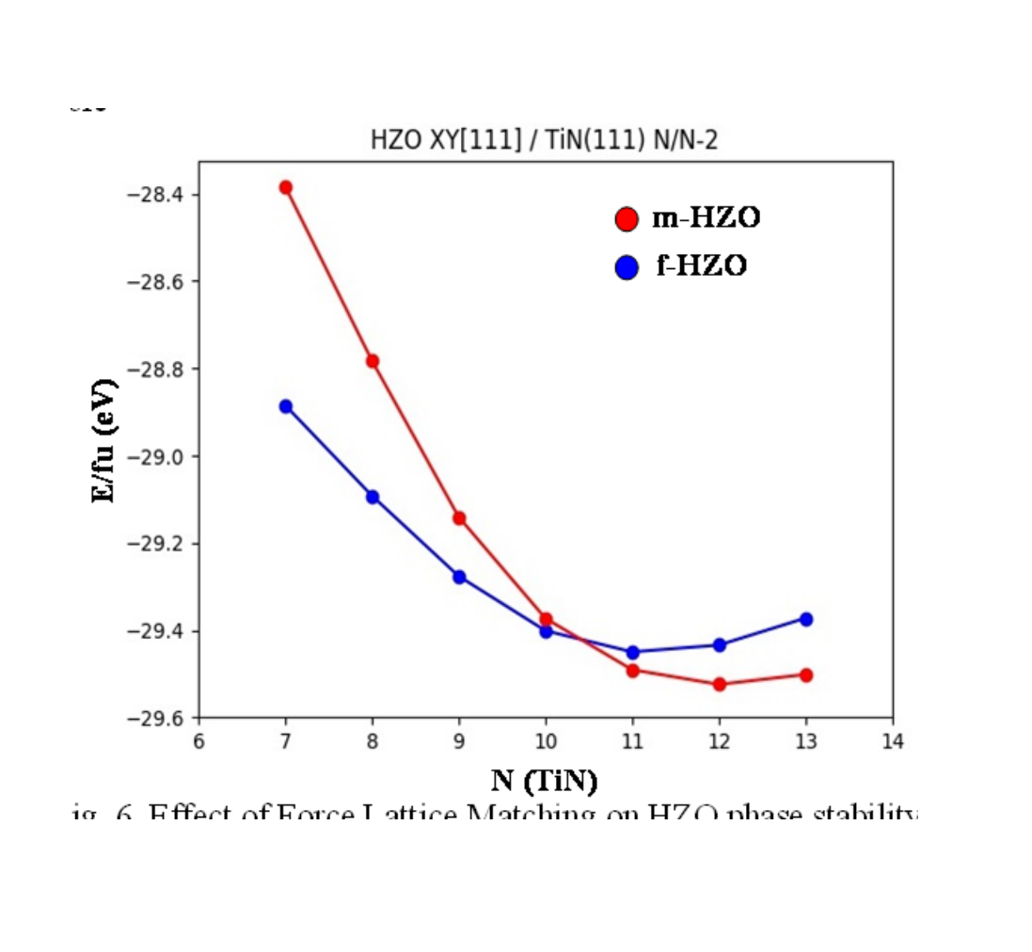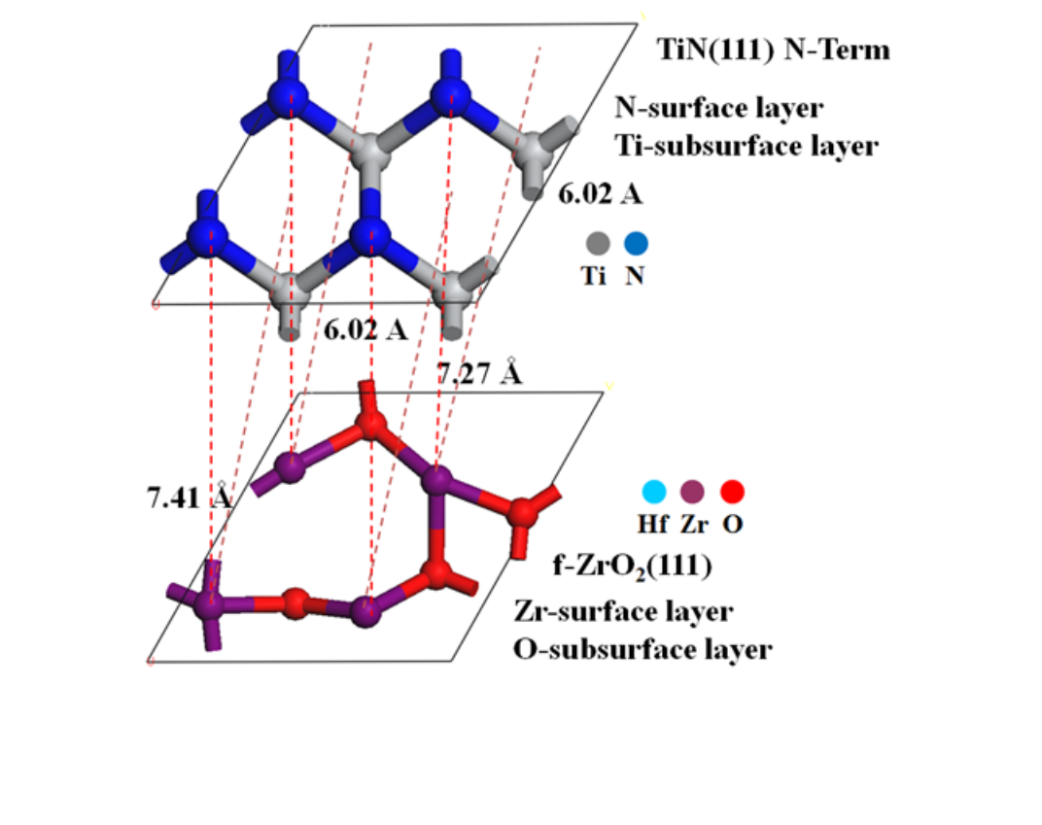

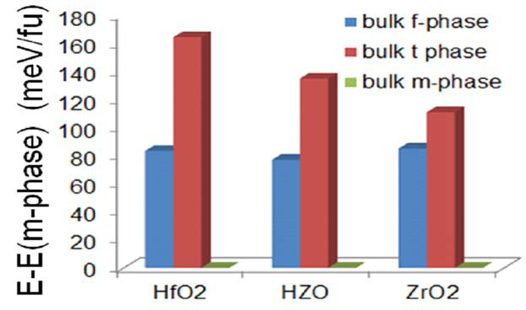

Fig. 1. DFT Calculation of Bulk Stability of the Phases of HfO2, Hf0.5Zr0.5O2, and ZrO2. The monoclinic is the reference state for all three phases so it is given a value of 0 meV. For all three oxides the ferroelectric f-phase is less stable by about 80 meV/fu.

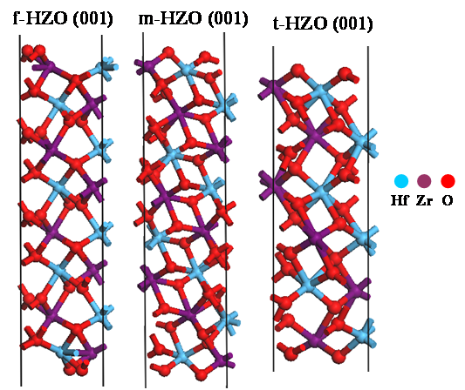

Fig. 2. DFT Simulation of the most stable surface of HZO low index faces. Note the bonding on all surfaces is O bonded to two Hf/Zr atoms so surfaces are chemically similar.

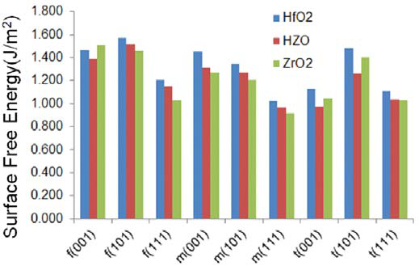

Fig. 3. DFT Calculation of Surface Free Energy of the (001), (101) and (111) surfaces of HfO2, Hf0.5Zr0.5O2, and ZrO2. The surface free energies of f(111), m(111), and t(111) are nearly degenerate.

Fig. 4. Unit cell of TiN(111) and f-phase ZrO2. Dimensions for HfO2 and HZO are within 3%. Approximate lattice matching will occur when there are about 9 ZrO2 unit cells for 11 Ti3N4 unit cells.

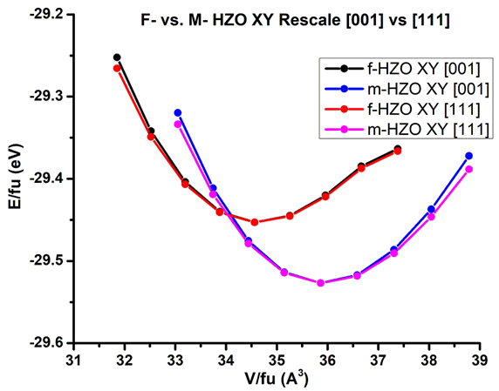

Fig. 5. DFT Simulation of biaxial compression of HZO along [001] and [111] axes. Note for about 5% compression, the f-phase is more stable

Fig. 6. Effect of Force Lattice Matching on HZO phase stability when there two extra TiN unit cells. When matching occurs over 10 or less unit cells of TiN, f-phase is more favorable based on biaxial compression

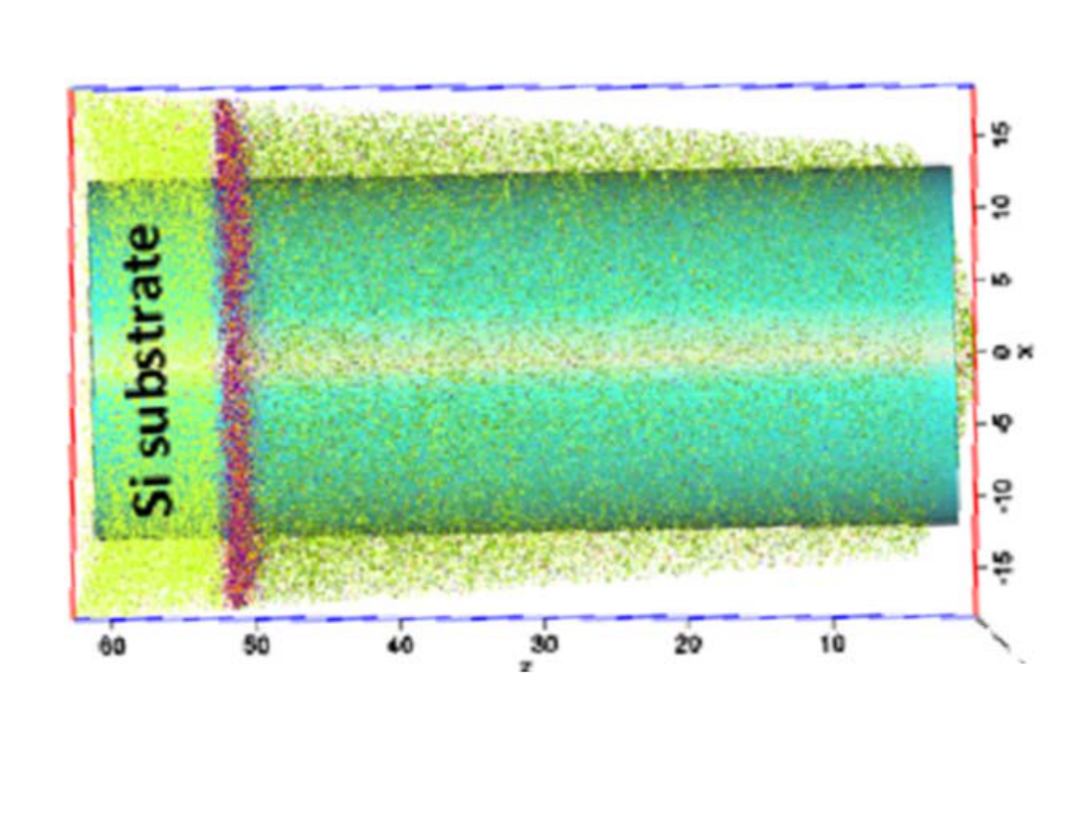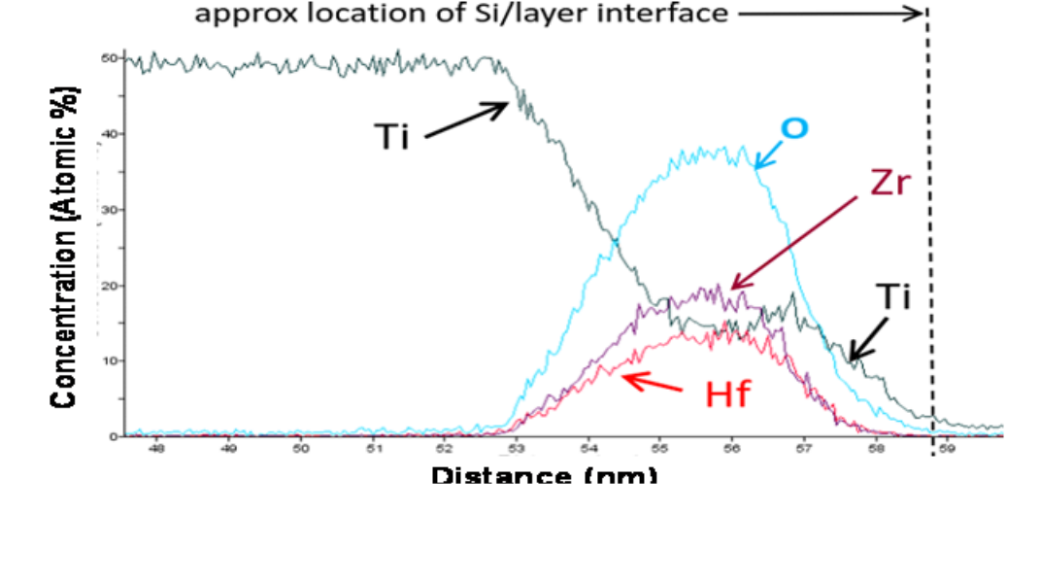

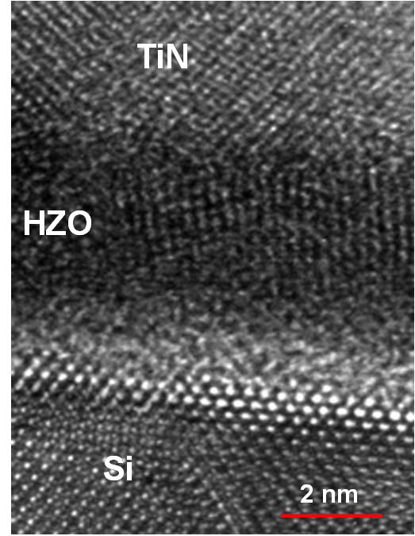

Fig. 7. TEM of TiN/HZO/Si cross section: The HZO atoms are in apparent registry with the TiN lattice. Note TiN may be Ti3N4. Note ~1 nm amorphous layer of native silicon oxide at the interface between Si and HZO.

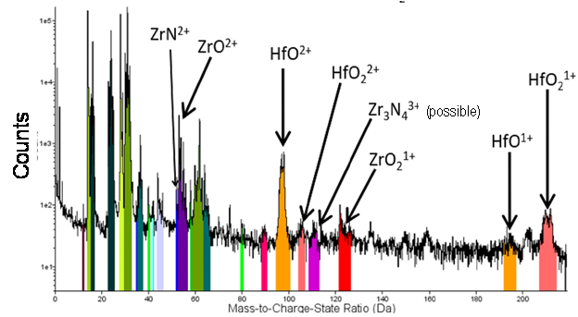

Fig 8: Typical atom probe tomography (APT) spectrum of TiN/HZO/Si from a single point. Note log scale.

Fig 9. APT Averaged in X-Y. Note Hf and Zr distributions differ and there is possible Ti on top of Si.

Fig 10: APT analysis confined to a region of interest (ROI) perpendicular to interface. This is the yellow cylinder in the center of the green cylinder

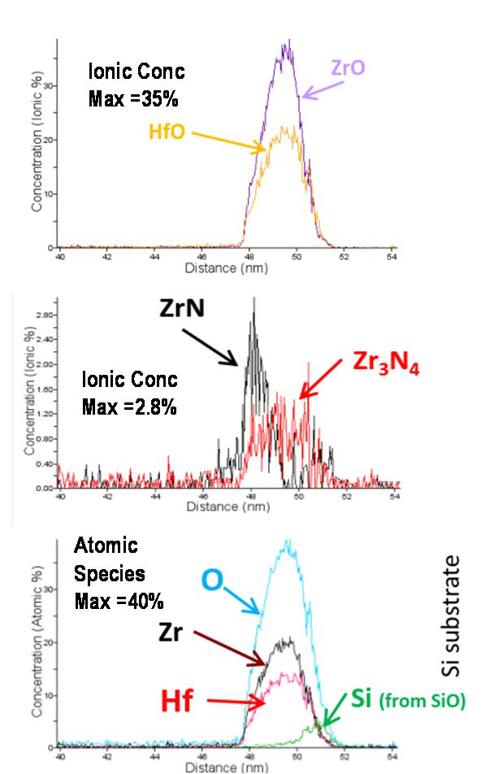

|  |
| --- |
| Fig 11: Ionic and atomic species from region of interest: HfO+ and  ZrO+ are most abundant species in ROI and profiles differ. Only  ZrNx + were detected and no HfNx +. |